Just be a Child

5 Lindens, Stevenage, SG1 1ST

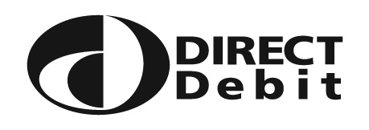
Instruction to your bank or building society to
pay by Direct Debit

Name of account holder
Service User Number

Bank/Building Society account number
Reference

Branch sort code

Name and full postal address of your
Bank/Building Society

Instruction to your Bank or Building Society Please pay Just be a Child Direct Debits from the account detailed in this Instruction subject to the safeguards assured by the Direct Debit Guarantee. I understand that this instruction may remain with Just be a Child and, if so, details will be passed electronically to my bank/building society.

Date

Banks and building societies may not accept Direct Debit Instructions for some types of account

The Direct Debit Guarantee

This Guarantee is offered by all banks and building societies that accept instructions to pay Direct Debits.

If there are any changes to the amount, date or frequency of your Direct Debit [Company name] will notify you 10 working days in advance of your account being debited or as otherwise agreed. If you request [Company name] to collect a payment, confirmation of the amount and date will be given to you at the time of the request.

If an error is made in the payment of your Direct Debit, by [Company name] or your bank or building society, you are entitled to a full and immediate refund of the amount paid from your bank or building society – if you receive a refund you are not entitled to, you must pay it back when [Company name] asks you to.

You can cancel a Direct Debit at any time by simply contacting your bank or building society. Written confirmation may be required. Please also notify [Company name].

